Design and apply context aware access controls based on user access controls based on user identity.

Group Details:
Team id: SWTID-2026-8261
Role | Name | Email-id
Team Lead | NAREN PRASANTH P | prasanthnarenprasanth@gmail.com
Team Member 1 | GOPINATH R | rangangopi30@gmail.com
Team Member 2 | SANTHOSH KUMAR S | santhoshkumar34962@gmail.com
Team Member 3 | ANBARASI S | 23bcaanbarasi@gmail.com

Project Details:
Title: Design and apply context aware access controls based on user access controls based on user identity.
Intro
Abstract:
AI-Enhanced User Protection (AIUP) is a security framework that combines identity-based access control with context-aware decision-making and machine learning to dynamically evaluate access requests. Unlike traditional static access models, AIUP continuously analyses user behaviour, environmental context, and risk signals (such as location, device, and activity patterns) to make intelligent, real-time access decisions.

Scenario 1: Remote Employee Access
An employee logs in from home using their corporate credentials. The system detects a new device and location. Access is granted only to low-risk resources until verification is completed.
- Enforce multi-factor authentication for unknown devices.
- Limit access to sensitive data until trust is established.
- Monitor session behaviour for anomalies.
Scenario 2: Admin Access to Critical Systems
A system administrator attempts to access production servers. The request is evaluated based on role, time, and device security posture. Elevated privileges are granted temporarily.
- Use just-in-time (JIT) access for admin roles.
- Require device compliance checks before access.
- Log and audit all privileged actions.

Scenario 3: Third-Party Vendor Access
A vendor logs in to perform maintenance on specific systems. Access is restricted to only required resources and during a defined time window. Any deviation triggers alerts.
- Apply least privilege access policies.
- Restrict access by time and IP range.
- Automatically revoke access after task completion.
Scenario 4: Suspicious Login Attempt
A user attempts to log in from a different country shortly after a local login. The system flags the behaviour as high risk. Access is blocked until identity is verified.
- Use geolocation and behaviour analytics.
- Trigger step-up authentication for risky logins.
- Temporarily lock account on high-risk detection.
Scenario 5: Internal User Accessing Sensitive Data
An employee tries to access confidential records not related to their role. The system evaluates role, department, and data sensitivity. Access is denied and logged.
- Implement role-based and attribute-based access control (RBAC + ABAC).
- Classify and tag sensitive data for policy enforcement.
- Generate alerts for unauthorized access attempts.

Stage 1:
Title:Owasp to 10
Overview:
Context-aware access control is a modern security approach that dynamically adjusts permissions based on the identity of the user and the context of their access request. Unlike traditional access control models that rely solely on static roles or permissions, this method evaluates multiple factors such as user identity, device type, location, time of access, and behaviour patterns. By incorporating these contextual signals, organizations can ensure that access decisions are more precise and aligned with real-time risk levels.
Designing such a system begins with establishing a strong identity foundation. This includes implementing robust authentication mechanisms like multi-factor authentication (MFA), single sign-on (SSO), and identity federation. User identities should be enriched with attributes such as roles, departments, and risk profiles. These attributes help define fine-grained access policies, ensuring that users only access resources necessary for their responsibilities, following the principle of least privilege.
The next step involves defining and enforcing context-aware policies. These policies evaluate conditions such as whether a user is accessing from a trusted network, using a compliant device, or logging in during normal working hours. For example, a user attempting to access sensitive data from an unfamiliar location or device may be required to undergo additional verification or may be denied access altogether. Policy engines and security frameworks like Zero Trust Architecture play a key role in continuously assessing these conditions before granting access.
Finally, continuous monitoring and adaptive response are essential for maintaining effective context-aware access control. Systems should track user behavior and detect anomalies, such as unusual login patterns or data access activities. When suspicious activity is identified, automated responses—such as session termination, step-up authentication, or alerting security teams—can be triggered. This ongoing evaluation ensures that access control remains dynamic, reducing the risk of unauthorized access while maintaining a seamless user experience.

List of vulnerabilities table:

S.No | Vulnerability name | CWE/CVE .no
1, | Relative Path Traversal | CWE-23
2. | Active debug code | CWE-489
3. | Use of Obsolete function | CWE-447
4. | Small Space of Random Values | CWE-334
5. | Process Control | CWE-114
6. | External control of file name or path | CWE-73
7. | Weak Password Requirements | CWE-521
8. | Missing Support for Integrity Check | CWE-353
9. | Insufficient Logging | CWE-778
10. | Unchecked Return Value | CWE-252

Vulnerability name: Relative Path Traversal
CWE no: CWE-23
OWASP Category: A01:2025 Broken Access Control
Description:
Relative Path Traversal is a web security vulnerability that occurs when an application allows users to access files and directories outside the intended directory. This happens when the application does not properly validate user-supplied input used in file paths. Attackers can manipulate file path parameters using special characters such as ../ to navigate to parent directories and access restricted files on the server. As a result, sensitive system files, configuration files, or application source code may become accessible to unauthorized users. This vulnerability is commonly found in web applications that dynamically load files based on user input without proper security checks.
Business impact:
- Unauthorized Access to Sensitive Files :Attackers may access restricted files such as configuration files, passwords, or system data.
- Data Leakage: Confidential business information, customer data, or internal documents may be exposed.
- System Compromise Risk: Attackers may read or modify important system files, leading to further attacks.
- Service Disruption: Unauthorized file access or manipulation can cause application crashes or downtime.
- Loss of Data Integrity: Critical files may be altered, affecting application functionality and reliability.

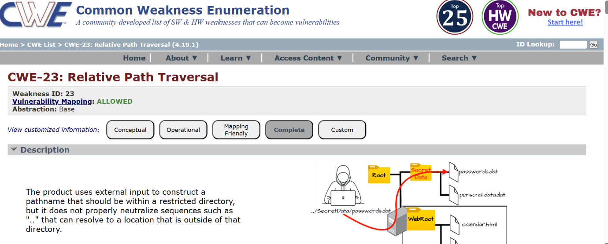

Vulnerability name: Active debug code
CWE no: CWE-489
OWASP Category: A02:2025 Security Misconfiguration
Description: Active debug code refers to debugging features or test code that remain enabled in a production environment. These debug functions are normally used by developers during application development to test and troubleshoot software. If they are not removed or disabled before deployment, attackers may exploit them to gather sensitive information about the system.
Business impact:
1. Exposure of Sensitive Information: Debug messages may reveal system details such as file paths, database queries, and configuration data.
2. Unauthorized Access Risk: Attackers may use debug interfaces to gain elevated or administrative access.
3. Increased Attack Surface: Debug features provide additional entry points that attackers can exploit.
4. Application Security Weakness: Internal application logic and system structure may be exposed, helping attackers plan further attacks.
5. Service Disruption: Exploiting debug functions may cause application malfunction or downtime.
6. Compliance and Regulatory Issues: Exposure of internal data can lead to non-compliance with security standards and regulations.
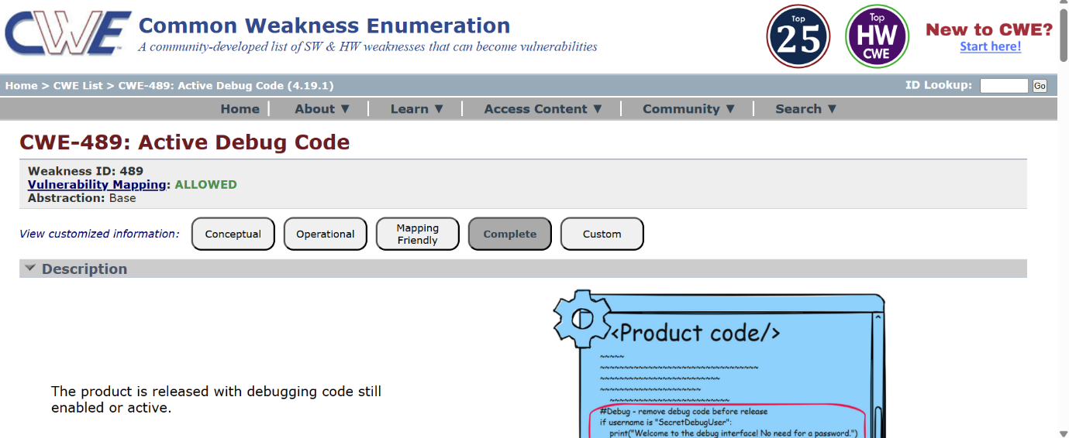

Vulnerability name: Use of Obsolete function
CWE no: CWE-447
OWASP Category: A03:2025 Software Supply Chain Failures
Description: The use of obsolete functions occurs when an application uses outdated or deprecated functions that are no longer recommended for secure software development. These functions may have known security weaknesses, lack proper maintenance, or may not follow modern security standards.
Business impact:
1. Security Vulnerabilities: Obsolete functions may contain known security flaws that attackers can exploit.
2. Reduced Application Reliability: Deprecated functions may not work properly with modern systems, causing application errors or failures.
3. Compliance Issues: Using outdated software components may violate security standards and regulatory requirements.
4. Reputation Damage: Security incidents caused by outdated code can reduce customer trust in the organization.
5. Operational Disruption: Exploitation of obsolete functions can lead to system downtime or service interruptions.

6. Financial Loss: Organizations may incur costs related to incident response, system recovery, and security updates.
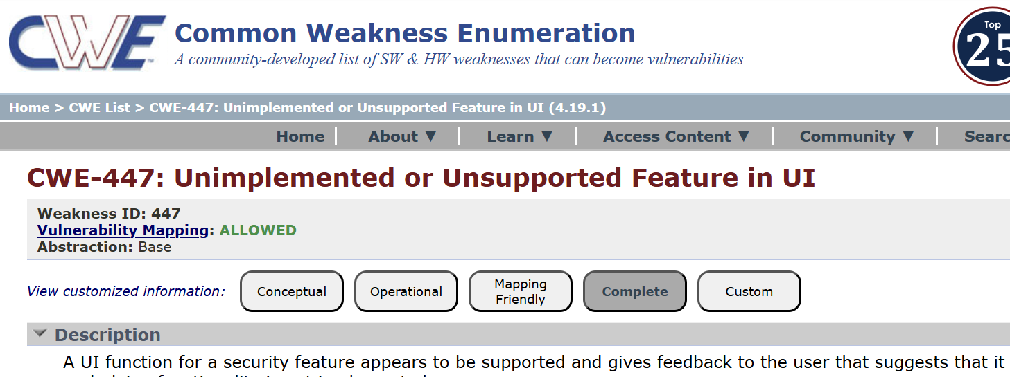

Vulnerability name: Small Space of Random Values
CWE no: CWE-334
OWASP Category: A04:2025 Cryptographic Failures
Description: The Small Space of Random Values vulnerability occurs when an application generates security-sensitive values (such as session IDs, tokens, passwords, encryption keys, or reset links) using a limited or predictable range of random numbers.
Business impact:
1. Account Takeover
Attackers may guess session tokens, authentication tokens, or password reset codes, allowing them to gain unauthorized access to user accounts.
2. Session Hijacking
Weak or predictable session IDs can allow attackers to impersonate legitimate users, leading to unauthorized actions within the application.
3. Unauthorized Data Access
Once attackers gain access to valid tokens or sessions, they may retrieve sensitive data, including personal information, financial records, or confidential business data.

4. Security Control Bypass
Authentication or authorization mechanisms that rely on predictable random values can be easily bypassed, compromising the security of the entire application.
5. Fraud and Financial Loss
In systems such as banking, e-commerce, or payment platforms, attackers could exploit predictable values to perform fraudulent transactions or misuse accounts.
6. Reputational Damage and Compliance Risks
Security breaches caused by weak randomness can damage customer trust and may result in regulatory violations, audits, or financial penalties.
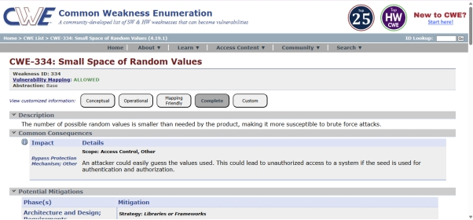

Vulnerability name: Process Control
CWE no: CWE-114
OWASP Category: A05:2025 Injection
Description: The Process Control vulnerability occurs when an application allows external input or untrusted data to influence the execution of system processes or load external code components, such as dynamic libraries or executables.
Business impact:
1. Remote Code Execution
Attackers may exploit the vulnerability to execute malicious code within the application’s process, potentially gaining full control over the system.

2. System Compromise
If the compromised application runs with elevated privileges, attackers could gain administrative access to the server or operating system.
3. Data Breach
Malicious code injected into the process may allow attackers to access, modify, or exfiltrate sensitive data, including customer information or proprietary business data.
4. Malware Injection
Attackers may install backdoors, ransomware, or other malware, allowing persistent access to the system.
5. Service Disruption
Compromised processes can cause application crashes, service failures, or denial of service, affecting business operations and customer services.
6. Financial and Reputational Damage
Successful exploitation can result in financial loss, legal liabilities, compliance violations, and reputational damage for the organization.

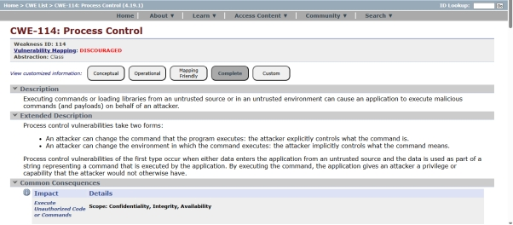

Vulnerability name: External control of file name or path
CWE no: CWE-73
OWASP Category: A06:2025 Insecure Design
Description:
External Control of File Name or Path occurs when an application allows users or external inputs to control the file name or file path used by the system without proper validation. This means attackers can manipulate input values to access, create, modify, or delete files on the server.
Business impact:
1. Unauthorized File Access: Attackers may access sensitive system files, configuration files, or confidential data.
2. Data Leakage: Important business or customer information may be exposed to unauthorized users.
3. File Manipulation Risk: Attackers may modify, overwrite, or delete critical application files.
4. Application or System Failure: Unauthorized file operations can cause application errors or service disruption.
5. Compliance Violations: Exposure or misuse of sensitive data may lead to regulatory and legal issues.
6. Reputation Damage: Security incidents can reduce user trust and harm the organization's reputation.
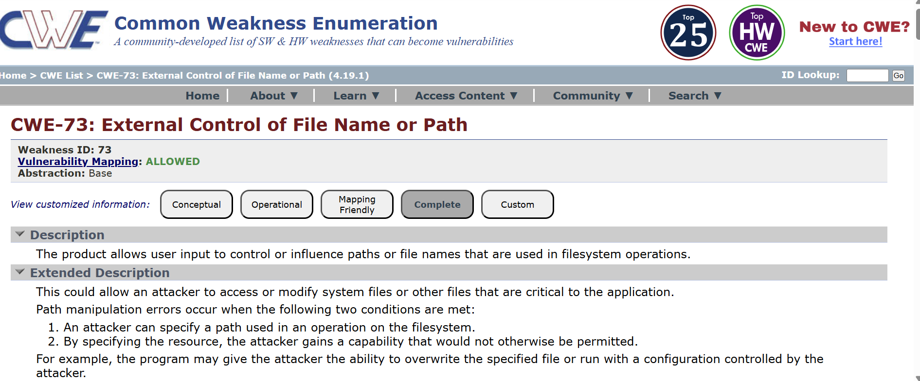

Vulnerability name: Weak Password Requirements
CWE no: CWE-521
OWASP Category: A07:2025 Authentication Failures
Description:
The Weak Password Requirements vulnerability occurs when an application allows users to create passwords that do not meet sufficient complexity or strength requirements. This includes passwords that are too short, predictable, commonly used, or lack a combination of character types.
Business impact:
1. Unauthorized Account Access
Weak passwords make it easier for attackers to guess or crack user credentials, allowing unauthorized access to accounts.
2. Account Takeover
Attackers may gain full control over user accounts and perform actions such as changing account settings, accessing sensitive data, or initiating unauthorized transactions.
3. Data Breach
Compromised accounts can expose personal information, financial data, or confidential business records, resulting in a data breach.
4. Privilege Escalation
If administrative accounts use weak passwords, attackers may gain elevated privileges, allowing them to control critical systems or infrastructure.
5. Financial Loss and Fraud
Unauthorized access to accounts can lead to fraudulent transactions, misuse of services, or financial theft.

6. Compliance and Reputational Damage
Failure to enforce strong password policies may violate security standards such as:
- PCI DSS
- GDPR
- ISO/IEC 27001
Security incidents caused by weak authentication practices can damage customer trust and organizational reputation.

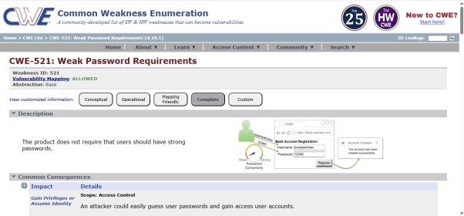

Vulnerability name: Untrusted Search Path
CWE no: CWE-426
OWASP Category: A08:2025 Software or Data Integrity Failures
Description:
Untrusted Search Path vulnerability occurs when an application loads or executes external programs, libraries, or files without specifying a secure and trusted path. Instead, the system searches for the required file in multiple directories defined in the system’s search path.
Business impact:
1. Unauthorized Code Execution: Attackers may place malicious files that the application executes instead of legitimate programs.
2. System Compromise: Malicious programs executed through the search path can take control of the system.
3. Data Breach Risk: Attackers may access or steal sensitive business or customer information.
4. Reputation Damage: Security incidents can reduce customer trust and harm the organization's credibility.
5. Service Disruption: Execution of malicious files may cause application failure or downtime.
6. Financial Loss: Costs may arise from incident response, recovery efforts, and security improvements.

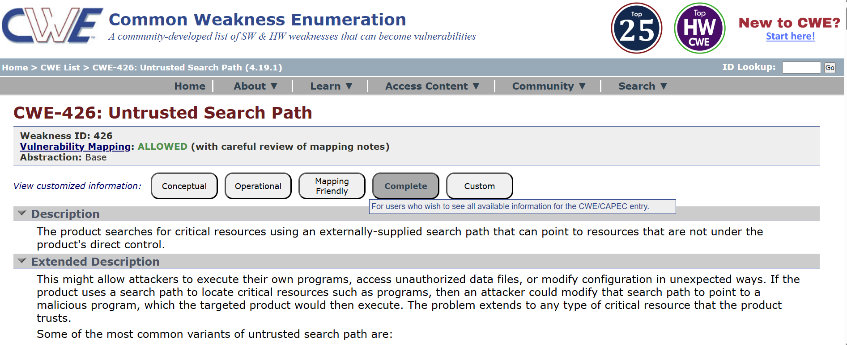
Vulnerability name: Insufficient Logging
CWE no: CWE-778
OWASP Category: A09:2025 Security Logging & Alerting Failures
Description:
The Insufficient Logging vulnerability occurs when an application fails to generate adequate logs for security-relevant events, such as authentication attempts, access to sensitive data, system errors, or configuration changes.

Business impact:
1. Delayed Detection of Security Incidents
Without proper logging, malicious activities such as unauthorized access or brute-force attacks may go unnoticed.
2. Difficulty in Incident Investigation
Inadequate logs make it difficult for security teams to identify the source, scope, and timeline of an attack during forensic analysis.
3. Increased Risk of Data Breaches
If attacks are not detected early, attackers may have more time to exfiltrate sensitive data or compromise systems.
4. Operational and Financial Loss
Undetected attacks may lead to service disruptions, data loss, or fraud, resulting in financial and operational damage.
5. Compliance Violations
Many security regulations require proper logging and monitoring, including:
- PCI DSS
- GDPR
- ISO/IEC 27001
Failure to maintain adequate logs may result in audit failures, penalties, or legal consequences.
6. Reputational Damage
Security incidents that go undetected due to poor logging can damage customer trust and the organization’s reputation.
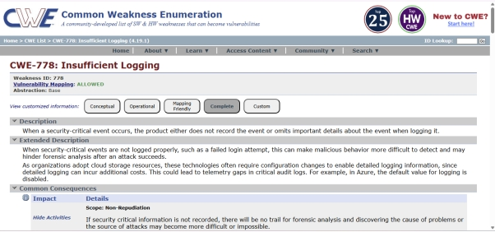

Vulnerability name: Unchecked Return Value
CWE no: CWE-252
OWASP Category: A10:2025 Mishandling of Exceptional Conditions
Description:
The Unchecked Return Value vulnerability occurs when an application fails to verify or properly handle the return value of a function or system call. Many functions return values that indicate whether an operation succeeded, failed, or encountered an error. If the application does not check these values, it may continue executing under the assumption that the operation was successful.
Business impact:
1. Security Control Bypass
If return values related to authentication or authorization checks are ignored, attackers may bypass security mechanisms and gain unauthorized access.
2. System Instability
Ignoring error conditions may cause the application to operate in an unexpected or inconsistent state, leading to crashes or system failures.

3. Data Corruption or Loss
Unchecked return values from file or database operations may result in incomplete transactions, corrupted data, or unintended modifications.
4. Increased Attack Surface
Attackers may exploit unchecked error conditions to trigger unexpected behaviors or vulnerabilities, potentially compromising the system.
5. Operational Disruption
System failures or malfunctioning applications caused by ignored errors can lead to service outages and operational disruptions.
6. Reputational and Financial Impact
Application failures and security incidents may result in financial loss, customer dissatisfaction, and reputational damage to the organization.
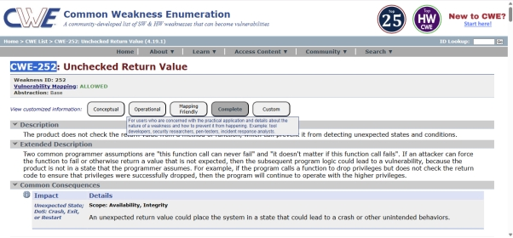

Stage 2:
Title:Nessus scan
Overview:
Designing context-aware access controls based on user identity in a Nessus scan environment starts with establishing a strong identity framework. Each user (e.g., security analyst, auditor, or administrator) must be uniquely authenticated using mechanisms like multi-factor authentication (MFA) and role-based identity attributes. These identities are mapped to specific access levels, ensuring that only authorized users can configure scans, view sensitive results, or export reports. This prevents unauthorized exposure of vulnerability data and aligns with the principle of least privilege.
The next step is to incorporate contextual parameters into access decisions. In addition to identity, the system evaluates factors such as user location, device security posture, time of access, and network environment. For example, a Nessus administrator logging in from a trusted corporate network may have full privileges, while the same user attempting access from an unknown location may be restricted or required to perform step-up authentication. This dynamic evaluation strengthens security by adapting access controls to real-time risk conditions.
Applying these controls within Nessus involves configuring user roles, scan permissions, and policy restrictions. Administrators can define which users can launch scans against specific targets, such as testphp.vulnweb.com, and limit access to scan configurations or plugin details. Integration with identity providers (IdPs) and directory services allows centralized control of user attributes and access policies. Additionally, audit logs and session monitoring ensure that all actions performed by users are tracked for accountability and compliance.
Finally, continuous monitoring and adaptive response are essential for maintaining effective context-aware access control. Behavioral analytics can detect anomalies, such as unusual scan activity or unauthorized attempts to access sensitive reports. When such events occur, automated responses—such as revoking access, alerting administrators, or enforcing stricter authentication—can be triggered. This approach not only secures the Nessus environment but also ensures that vulnerability management processes remain resilient, compliant, and aligned with modern Zero Trust security principles.

Target website http://testphp.vulnweb.com/
Target ip address: 199.191.50.185

S.no: | Vulnerability name | Severity | Plugins
1 | Port scanners | Info | 11219
2 | Service detection | Info | 22964
3 | General | Info | 45590
4 | General | Info | 54615
5 | DNS | Info | 11002

1. Port scanners
- Severity: Info
- Plugin: 11219
- Description: Port scanners are tools used to identify open ports and services running on a target system. This plugin detects systems that appear to be performing port scanning activity on the network. Port scanning is commonly used by administrators for network management and troubleshooting, but it can also be used by attackers to discover vulnerable services. The detection indicates that a host may be probing multiple ports to gather information about available network services..
- Solution:
Monitor the system or host that is performing the port scanning activity and verify whether the scanning is authorized. If the activity is not legitimate, block or restrict the suspicious IP address using firewall rules. Implement intrusion detection or prevention systems (IDS/IPS) to detect and prevent unauthorized scanning. Regularly review network logs and apply proper network security policies to limit unnecessary access to network ports.
- Business Impact:
Port scanning activity may indicate that a system is attempting to discover open ports and running services on the network. While it may be part of legitimate administrative tasks, unauthorized scanning can be an early stage of a cyber-attack. Attackers may use the information gathered to identify vulnerabilities, exploit services, and gain unauthorized access to systems. This could potentially lead to data breaches, service disruption, or compromise of sensitive business information if not monitored and controlled.

2. Service detection
. Severity: Info
- Plugin: 22964
- Description: This plugin detects and identifies the services running on open ports of a target system. It attempts to determine the service type, version, and protocol being used. Service detection helps administrators understand which applications are running on their network systems.
- Solution:
Review the detected services and verify that only required and authorized services are running on the system. Disable or remove unnecessary services to reduce the attack surface. Keep all services updated with the latest security patches and configure proper firewall rules to restrict access.
- Business Impact:
Service detection itself is informational, but exposed or unnecessary services may provide attackers with information about the system. If vulnerable services are running, attackers may exploit them to gain unauthorized access, potentially leading to system compromise, data loss, or service disruption.

3. General
- Severity: Info
- Plugin:
- Description:
This plugin provides general information gathered during the vulnerability scan. It does not indicate a specific vulnerability but reports details about the scanned system, such as detected configurations, responses from services, or other informational findings that may help in security analysis.
- Solution:
Review the information provided by the scan results and ensure that system configurations follow organizational security policies. Keep systems updated, remove unnecessary services, and regularly monitor logs to maintain proper security practices.

- Business Impact:
Since this is an informational finding, it does not directly impact system security. However, the information collected can help administrators understand the system environment and identify potential areas that may require security improvements if misconfigurations are present.

4. General
- Severity: Info
- Plugin: 54615
- Description:
This plugin provides general informational details collected during the vulnerability scan. It may report system responses, configuration information, or other non-vulnerable findings that help identify the system environment and network behaviour. It does not indicate an actual security vulnerability but provides useful diagnostic information.
- Solution:
Review the scan results and verify that the reported configurations and system information are expected. Ensure proper system configuration, keep software updated with the latest patches, and restrict unnecessary services or information exposure where possible.
- Business Impact:
This finding is informational and does not directly pose a security risk. However, the disclosed system information may help administrators better understand the network environment. If sensitive details are exposed, attackers could potentially use that information to plan future attacks, so monitoring and proper configuration are important.

5. DNS
- Severity: Info
- Plugin: 11002
- Description:
This plugin gathers Domain Name System (DNS) information from the target host. It checks whether the system responds to DNS queries and may identify DNS server details, domain names, or related configuration information. This is an informational finding and does not indicate a direct vulnerability.

- Solution:
Ensure that DNS services are properly configured and only necessary DNS queries are allowed. Restrict public access to internal DNS servers where possible, apply proper firewall rules, and keep DNS server software updated with the latest security patches.
- Business Impact:
Although this is an informational finding, exposed DNS information may reveal details about the network structure or domain configuration. Attackers could potentially use this information to map the network or plan further attacks if proper security controls are not in place.

Stage 3
Title: Design and apply context aware access controls based on user access controls based on user identity.
Overview
Context-aware access control is a modern security approach that dynamically regulates user access based on identity and contextual factors. In environments using tools like Nessus, traditional static access control is not sufficient. Instead, access decisions are made by evaluating multiple parameters such as user identity, device condition, and application sensitivity. This ensures that only authorized users can perform critical actions like initiating vulnerability scans or accessing sensitive reports.

Identity
User identity is the core of access control, where each user is authenticated using secure mechanisms such as Multi-Factor Authentication (MFA) and Single Sign-On (SSO). Based on roles and attributes, permissions are assigned to ensure that users can only access what is necessary for their responsibilities. This helps enforce the principle of least privilege and reduces the risk of unauthorized access.

Device Posture
Device posture refers to the security condition of the device used to access the system. Factors such as updated operating systems, antivirus protection, encryption, and compliance with organizational policies are evaluated. Even if a user has valid credentials, access may be denied or restricted if the device is not secure, thereby preventing potential threats from compromised endpoints.

Application Risk
Application risk considers the sensitivity and vulnerability level of the target system. For example, applications like testphp.vulnweb.com are intentionally vulnerable and require stricter access control. High-risk applications demand stronger authentication, limited access, and continuous monitoring to prevent exploitation and ensure secure operations.

Context-Aware Access
Context-aware access combines identity, device posture, and application risk to make real-time access decisions. A user accessing Nessus from a trusted device and network may receive full access, while the same user from an untrusted environment may be restricted or required to complete additional verification. This approach aligns with Zero Trust principles, ensuring continuous validation before granting access.

Stage 1: Broken Access Control
Broken Access Control occurs when users can access resources or perform actions beyond their permissions. This includes unauthorized access to admin functions, privilege escalation, and data manipulation. This stage highlights the importance of implementing strict identity-based controls to prevent misuse and protect sensitive systems.

Stage 2: Vulnerability Testing (Nessus Scan)
In this stage, vulnerability assessments are conducted using Nessus to identify issues such as SQL Injection, Cross-Site Scripting, and misconfigurations. When scanning targets like testphp.vulnweb.com, it is essential to ensure that only authorized users can initiate scans and access results, maintaining security and confidentiality.

Knowledge from Previous Stages
The first stage highlights the risks of weak access control, while the second stage demonstrates how vulnerabilities are identified through scanning. Combining these insights emphasizes the need to secure both systems and the tools used for testing. Context-aware access control ensures that vulnerabilities are not exploited due to improper access permissions.

Future Scope
Stage 1: Access Control Enhancement
In Stage 1, future improvements focus on strengthening access control mechanisms by adopting advanced models such as Attribute-Based Access Control (ABAC) and enhancing Role-Based Access Control (RBAC). Organizations can implement continuous authentication and behaviour analysis to ensure that user identity is constantly verified. Integrating these controls with systems like Nessus helps prevent unauthorized access and reduces the risk of Broken Access Control by ensuring strict enforcement of user permissions.

Stage 2: Enhanced Vulnerability Testing
In Stage 2, the focus shifts to improving vulnerability assessment processes. This includes automating scans using Nessus, integrating results with Security Information and Event Management (SIEM) systems, and prioritizing vulnerabilities based on risk levels. When scanning targets such as testphp.vulnweb.com, secure access policies must be enforced to ensure that only authorized users can initiate scans and view sensitive results, thereby maintaining data integrity and confidentiality.

Stage 3: Advanced Security with Zero Trust 2.0
In Stage 3, the future scope involves adopting Zero Trust 2.0, which enhances traditional Zero Trust models by incorporating AI-driven threat detection, adaptive access control, and continuous risk assessment. This approach ensures that every access request is evaluated in real time based on user behaviour, device posture, and contextual risk factors. By implementing Zero Trust 2.0, organizations can create a highly resilient and intelligent security framework that proactively detects and responds to evolving cyber threats while ensuring secure access to critical systems and data.

